KIRBY MUXLOE CRICKET CLUB
RETURN TO CRICKET GUIDELINES
The purpose of this document is to outline the risk management strategies and responsibilities of all members effective immediately, enabling the safe return of recreational cricket at Kirby Muxloe Cricket Club.
These guidelines have been agreed by the committee after comprehensive review of Government, ECB and Leicestershire & Rutland Cricket League Guidance.
KMCC expect all members who are interested in playing or spectating to read, confirm understanding and abide by these conditions until further formal communication is issued in due course.
This guidance applies to all guests and spectators also, we ask that you make efforts to share the content of this document with anyone you may invite.
Access Requirements:
- KMCC will maintain a selection policy using existing player records in accordance with the regional lockdown zones.
- All players must ensure that up to date contact information is provided to the club to allow an effective track and trace contact system if required.
- All players and guests are advised to self-screen before entry to the ground and must not attend if they, or any known persons they have been in proximity of are displaying symptoms of COVID-19.
- All players and guests must follow the displayed entry and exit routes when arriving at; and leaving the ground.
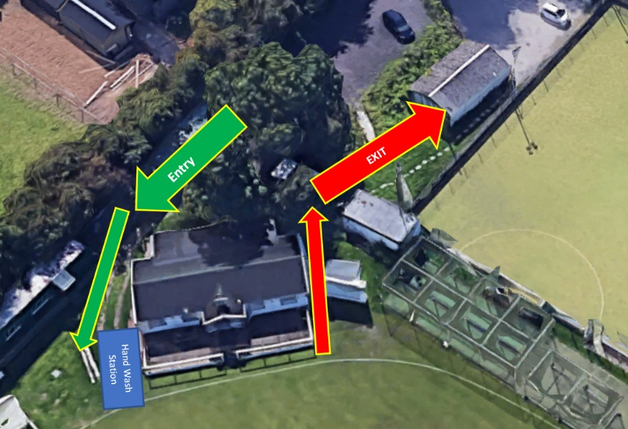
- All persons must use the available sanitisation upon entry to the ground. (Located at the outdoor BBQ area).

Facilities Access:
- Only playing members will be allowed access to the pavilion.
- No more than 4 x players will be allowed in each changing room at any given time. This applies to both the Home and Away dressing rooms individually. (8 x persons max capacity, 4 home, 4 away).
- Only 2 x person will be allowed to access each changing room toilet and shower facilities at a time.
- Guests will only be allowed access to the disabled toilet facilities at the rear of the pavilion and must sanitise before and after use.
- The pavilion will be prepared for access with all doors and windows fixed as open. Please limit your contact with touchpoints however possible.
- Designated persons will be appointed to complete opening, cleaning and closing of the pavilion before and after each game.
- A maximum of 10 x persons will be permitted access to the decking at any given time and must ensure they practice social distancing throughout.
- We ask that all players and guests bring their own chairs, refreshments (including tea and drinks), sanitisers, shower gel and do not share these.
- Regulation may differ in the main Sports Club building, all players and guests must abide by their regulations.

Playing Rules:
- ECB guidance dictates that a hygiene break is required every 20 minutes or 6 overs, whichever the sooner.
- No persons must share or ask another person to hold onto any equipment unless fully sanitised before and after handover.
- Contact must be avoided when celebrating.
- Spitting is prohibited, as is shining of the ball with use of saliva. The ball must be sanitised or discarded if there is any contravention.
- Non striking batsman must remain in the displayed “running zone” as per ECB regulations.
- Play will be suspended in the event of rain and players must remain socially distant, outside of the pavilion whilst waiting for play to resume.

General Considerations:
- Ensure self-screening of yourself and your families before arrival at the ground.
- Bring your own sanitisation equipment / PPE wherever possible. KMCC will obtain essential provisions.
- Avoid key touchpoints
- Maintain social distancing throughout
- Observe and adhere to all signage at the ground.
- Familiarise yourself with the current ECB Return to Cricket plan here: https://resources.ecb.co.uk/ecb/document/2020/07/09/f20adb12-c1d2-4cdc-b2e3-80b0c7873fe4/ECB_return_to_cricket_plan_for_step_4_July_2020.pdf

In order to maintain a robust risk management strategy KMCC request that all members confirm their understanding of and agreement to the guidelines outlined within this document.
A link will follow shortly for your acceptance.
In this ever-changing landscape we welcome feedback and requests for clarification.
Many thanks,
The Committee.

